**CREATE NODE RED SERVICES**

|  |  |
| --- | --- |
| **TEAM ID** | **PNT2022TMID12112** |
| **PROJECT NAME** | **PROJECT – IOT-BASED SAFETY GADGET FOR CHILD**  **SAFETY MONITORING AND NOTIFICATION** |

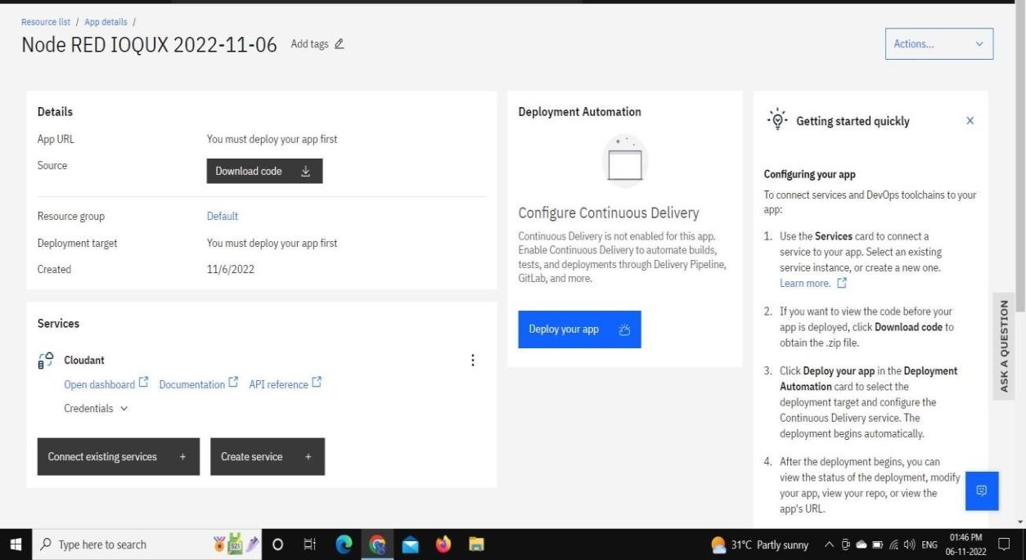

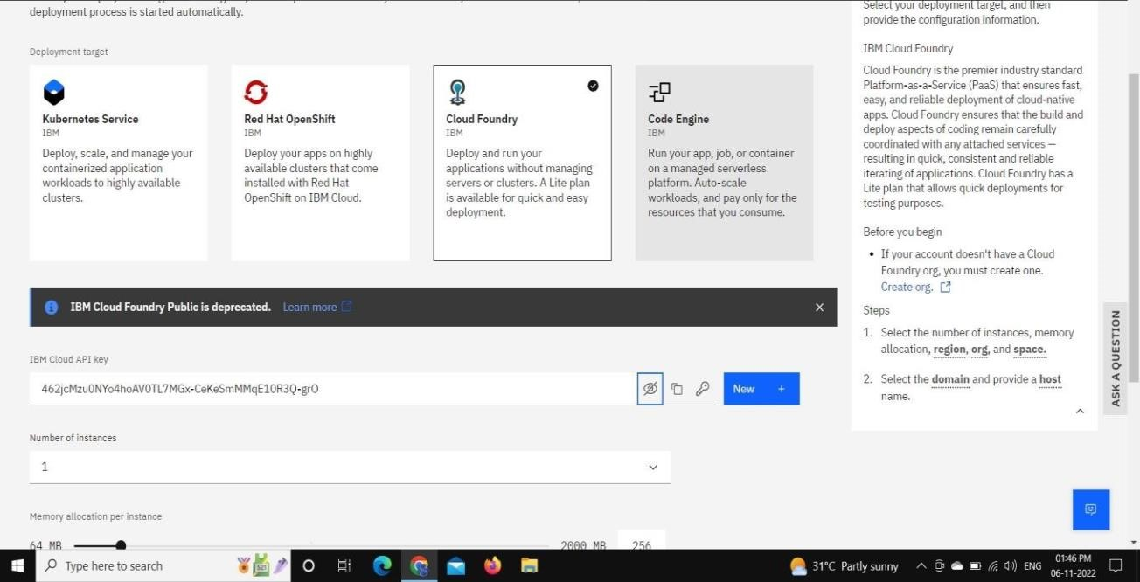

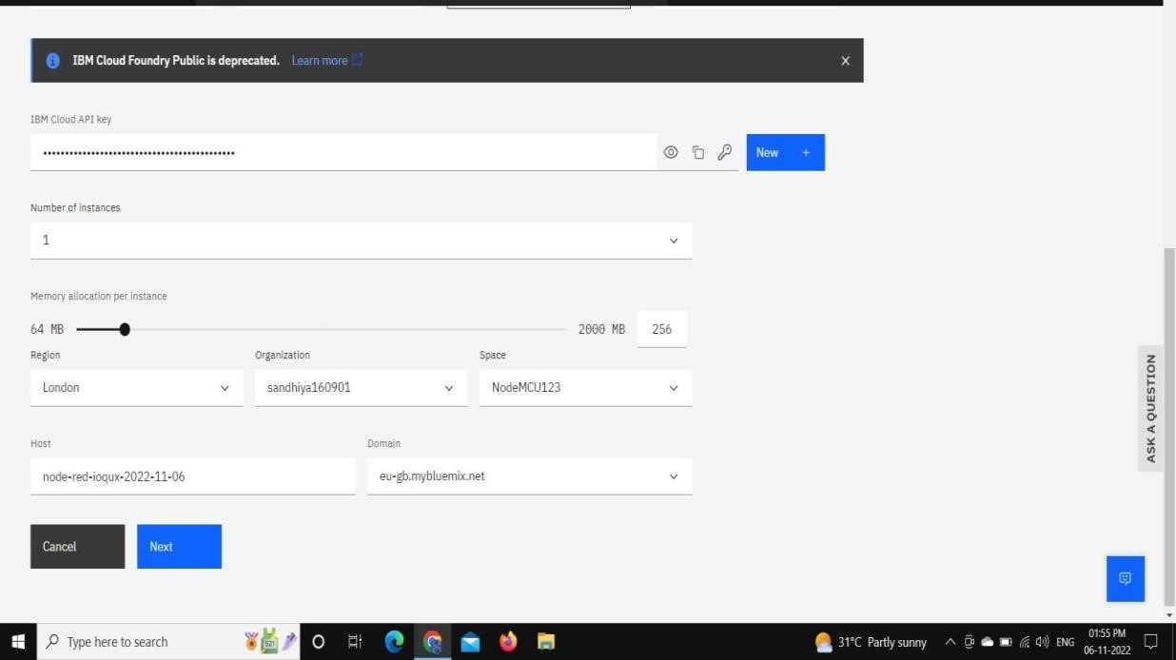

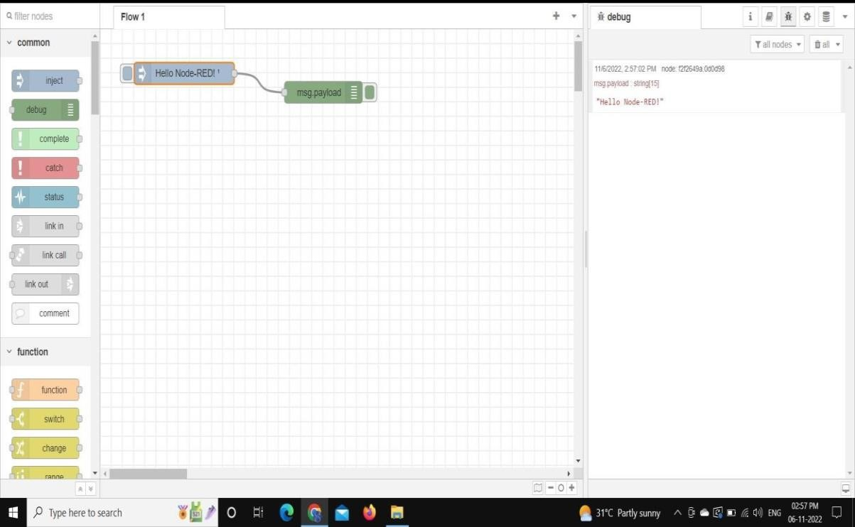

**RESULT:**

Thus node red service is created.